Experimental and Computational Study of the Temperatures Field Around a Chimney Roof Penetration
Article in Fire Technology · January 2016
Impact Factor: 1.30 · DOI: 10.1007/s10694-015-0540-8
- 
1st Manuela Neri
4.26 · Università degli Studi di Brescia
- 
2nd Perttu Leppänen
3.81 · Tampere University of Technology
- 
3rd Sandro Bani
2.55 · ANFUS
- 
Last Mariagrazia Pilotelli
4.26 · Università degli Studi di Brescia
Show 1 more authors
Abstract
The number of roof fires due to the passage of chimneys is high. Since the experimental procedure necessary to identify all the variables affecting the temperature reached by roof in the vicinity of a chimney would be expensive, a 2D numerical model for the estimation of the temperatures in the roof has been designed. The model has been validated by means of experimental tests in which a certified chimney has been installed in three roofs and spaced from flammable materials as prescribed by the manufacturer. In order to reproduce the diverse conditions that may occur in real installations, the clearance between chimney and roof has been sealed in three ways (sealed with insulating panels, sealed with metal sheets, and filled with insulating materials). Good agreement between measured and estimated data is shown, and the estimated temperatures are in favour of safety. The effects of the clearance sealing mode and the chimney installation quality on flammable materials temperature are also shown.

Analysis of the temperatures measured in very thick and insulating roofs in the vicinity of a chimney
Conference Paper in Journal of Physics Conference Series 655(1) · June 2015
DOI: 10.1088/1742-6596/655/1/012019
Conference: UIT 2015, Heat Transfer Conference, At L'Aquila - Italy
1st Manuela Neri
4.26 · Università degli Studi di Brescia
- 
2nd Davide Luscietti
3.05 · Università degli Studi di Brescia
3rd Sandro Bani
2.55 · ANFUS
Last Mariagrazia Pilotelli
4.26 · Università degli Studi di Brescia
Show 1 more authors
Abstract
Chimneys convey exhaust gas produced in domestic heat appliances to the external environment and to do this they have to pass through elements such as roofs and floors. If these elements are made up of flammable materials the fire hazard may occur. In some European countries the number of roof fire is very high and they affect also certified chimneys, that is, tested following the prescription of the related standards. The aim of this paper is to highlight that the certification procedure does not allow to test chimneys in the worst condition, therefore, chimney installed following the manufacturer prescriptions may in some cases cause the overheating and subsequent roof fire. To do this, experimental tests have been performed for measuring the temperature on roofs in the vicinity of a certified chimney. The results show that the certification procedure should be revised.
Figures
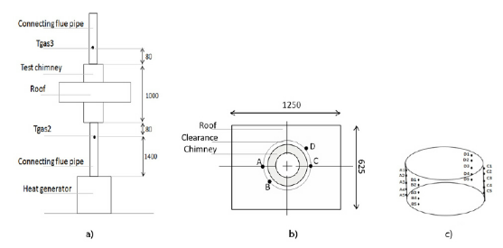Enlarge
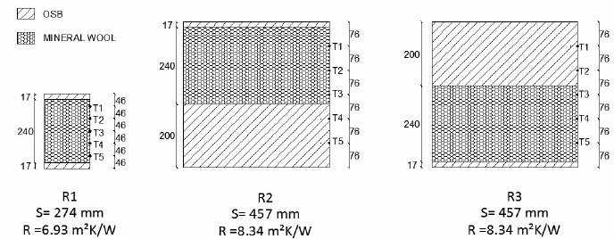Enlarge
+ 7

CHIMNEYS IN WOODEN ROOFS: A 3D STEADY NUMERICAL MODEL FOR THE PREDICTION OF THE TEMPERATURES
Conference Paper · June 2015
Conference: ASME-ATI-UIT-2015, At Napoli - Italy
1st Manuela Neri
4.26 · Università degli Studi di Brescia
2nd Davide Luscietti
3.05 · Università degli Studi di Brescia
3rd Sandro Bani
2.55 · ANFUS
Last Mariagrazia Pilotelli
4.26 · Università degli Studi di Brescia
Show 1 more authors
Abstract
Chimneys convey exhaust gas produced in domestic heat appliances to the external environment and to do this they have to pass
through floors and roofs: if these elements are made up of flammable materials, the fire hazard may occur. This article presents
the verification of a 3D numerical model set for the determination of the stationary temperatures reached on the flammable
materials in the vicinity of chimneys. The verification has been done comparing the temperatures measured in experimental
tests with those estimated by means of the numerical model. Results show that the 3D numerical model is a valid tool for the
analysis of heat transfer between chimney and roof. Since in the experimental tests it is not always possible to reach stationary
temperatures, a lumped element model to estimate them is also proposed and it could support the chimney certification.

